**EE414 Embedded System**

**20180745 – Tung-Duong Mai**

**Lab 2. LED Driver**

1. Purpose:

Understand how to drive the GPIO LEDs in Beaglebone (in particular, we learn to drive LED device on Beaglebone in user space).

Understand and compare 2 methods for LED drive:

1) Using sysfs in shell script.

2) Using mmap in application

GPIOs manipulation is a very crucial interface to connect the microcontroller with electronic devices. There are multiple methods to control the GPIO. We will experiment with two mentioned methods in this lab and see their mechanism, operations, pros and cons.

Target board: Beaglebone (containing 4 GPIO LEDs) with Linux.

Host computer: PC with Linux, cross compiler, NFS, and minicom.

1. Experiment sequence:
2. Setup cross development environment:
3. Connection

Connect Beaglebone with Ethernet cable and Power adapter.

Connect Beaglebone with Linux PC by USB cable.

By this, the PC can access the Beaglebone via the network or USB.

1. Start PC NFS server:

After this step, PC can act as NFS server and it waits for Beaglebone to mount as an NFS client.

1. Connect to Beagle bone:

Using minicom or ssh

Difficulty in this step:

I face some errors while connecting:

* Minicom lock file is stale
* My password does not pass
* ECDSA host key is changed

Possible reason: long period of inactivity

Solve:

* Reboot the Beaglebone using Debian (Default) credentials.
* Remove the compromised host key (using ssh-keygen)

I chose ssh connection method since it is more reliable (I was worried that the stale lock file might happen again) and more intuitive (I can execute directly from the PC terminal without switching to minicom interface)

1. Start Beaglebone nfs client

I switch to root user to have enough permission to run sysfs command (I tried give gpio permission to john (my user) but there is some incompatibility, so I think it is the best to just run in root)

Now, the Beaglebone can access the directory on PC that we setup in the previous lab. We are ready for cross development.

NFS or scp both work correctly. However, I think NFS is more intuitive since it gives me the sentiment that the data are shared and I can work as if the data is locally stored (for scp, I have to explicitly transfer the data).

1. Test LEDs using sysfs and commands:

This step aim to experiment the 1st way to control LED (sysfs – file system)

1. Select LEDs for test:

There are 4 LEDs and we will choose to test user 0 LED (the heartbeat signal)

1. Check sysfs file

* gpio
* gpiochip32 (GPIO1_0 to 31)

After this step, we can see the general structure of Beaglebones file system for GPIO

1. Find LED sysfs (/sys/class/leds)

After this step, we can locate the directory to control the LED

1. Get access right to user0LED

After this step, we can see the correspondence between the trigger and the actual state of the LED, and experiment with control the LED via change the trigger.

1. Control on/off of the usr0 LED

After this step, we can see the correspondence between the brightness and the actual state of the LED, and experiment with control the LED via change the brightness.

1. Control periodic on/off of usr0 LED

After this step, we can set the duty and period for the LED.

1. Test LEDs with shell script:

This steps simply combine previous command line into the script with 2 arguments to set delay on and off (to control period and duty).

After that, we run to check the effect on the user LED.

1. Control LED with C and mmap

This step aim to experiment the 2nd way to control LED (mmap – memory mapping):

1. Build shell script to stop & restore user LEDs

(This is to make sure that we do our experiment atomically, and don’t yield any bad effect)

1. Test example program: pushLEDmmap.c with pushLEDmmap.h

The program actually controls the external LED (connected to GPIO0_31) via external push button (connected to GPIO_07). So, we simply just make sure that our code run well and we can read and write normally with memory-mapped address.

The code map using mmap and unmap using munmap. The signal handler is used to catch Ctrl+C from the user to stop the program.

We make a Makefile for convenient compile and check the code.

1. Test example program: userLEDmmap.c

The program simple try to blink the usr1 LED. We aim to check if the mapping work

We adapt from the pushLEDmmap code, but change map and unmap argument to fit with GPIO1. usrLED 0, 1, 2, 3 is accessed by GPIO1_21, GPIO1_22, GPIO1_23, GPIO1_24. We set and reset the bits in GPIP_SETDATAOUT and GPIO_CLEARATAOUT to set/reset the bit in the corresponding register.

We simply repeat: set the 22-th bit to 1, sleep 1s, reset the 22th bit and sleep 1s.

1. Test Metronome_led application program

We modify the steps in the loop from last step to fit the 6/8 time signature, tempo 60 bpm and duty 50%. That means we should turn on the corresponding LEDs. Sleep 0.5s, turn off all the LEDs and sleep 0.5s.

We decide the bit to turn on based on the sequence [7, 1, 1, 3, 1, 1].

7 <-> 0111 so we turn on usr0, usr1, usr2 LED.

3 <-> 0011 so we turn on usr0, usr1 LEDs.

1 <-> 0001 so we turn on usr0 LED.

1. Experimental results:
2. Setup cross development environment:

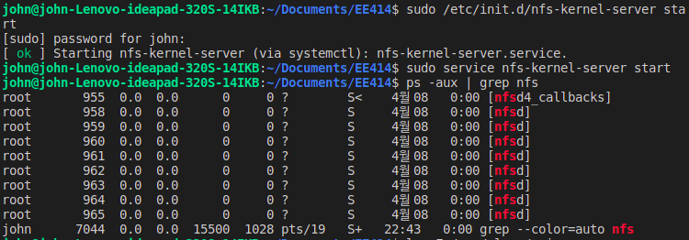

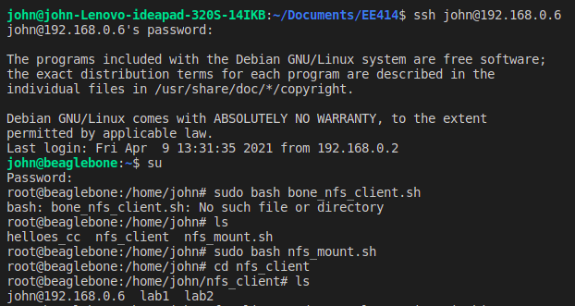

1. Test LEDs using sysfs and commands:

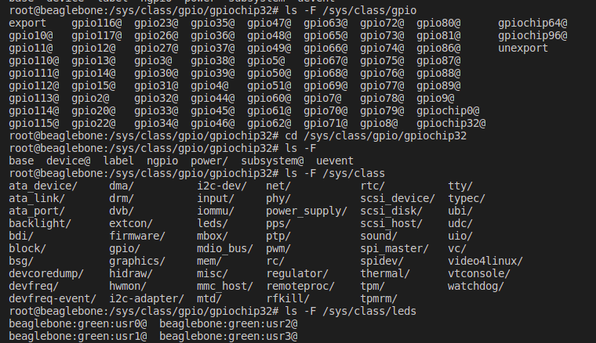

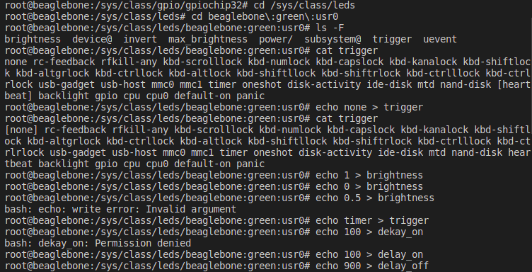

Normal state:

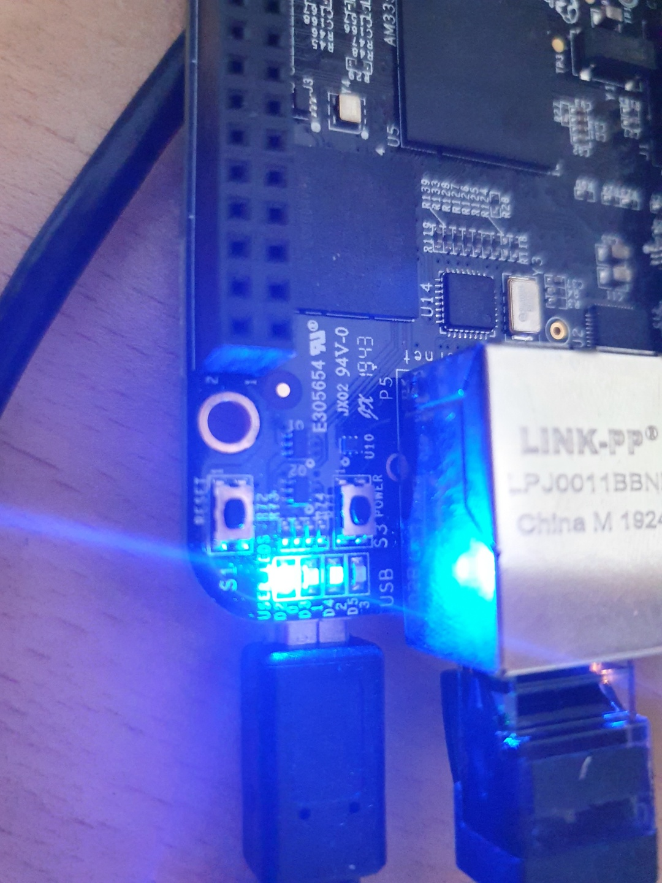

Usr0 LED stop after we pass none to trigger

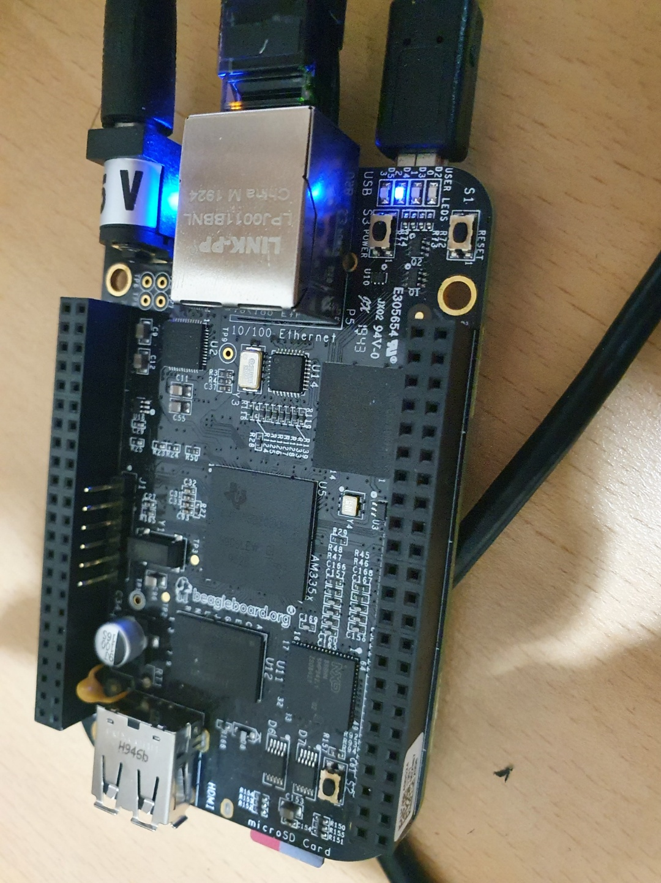

Usr0 LED stop after we pass 0 to brightness and bright again when we pass 1

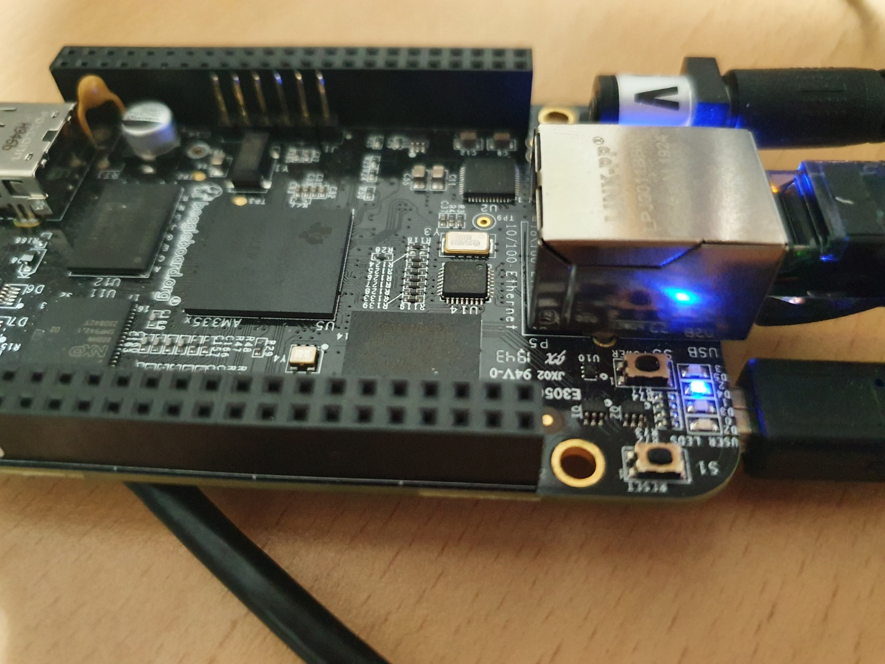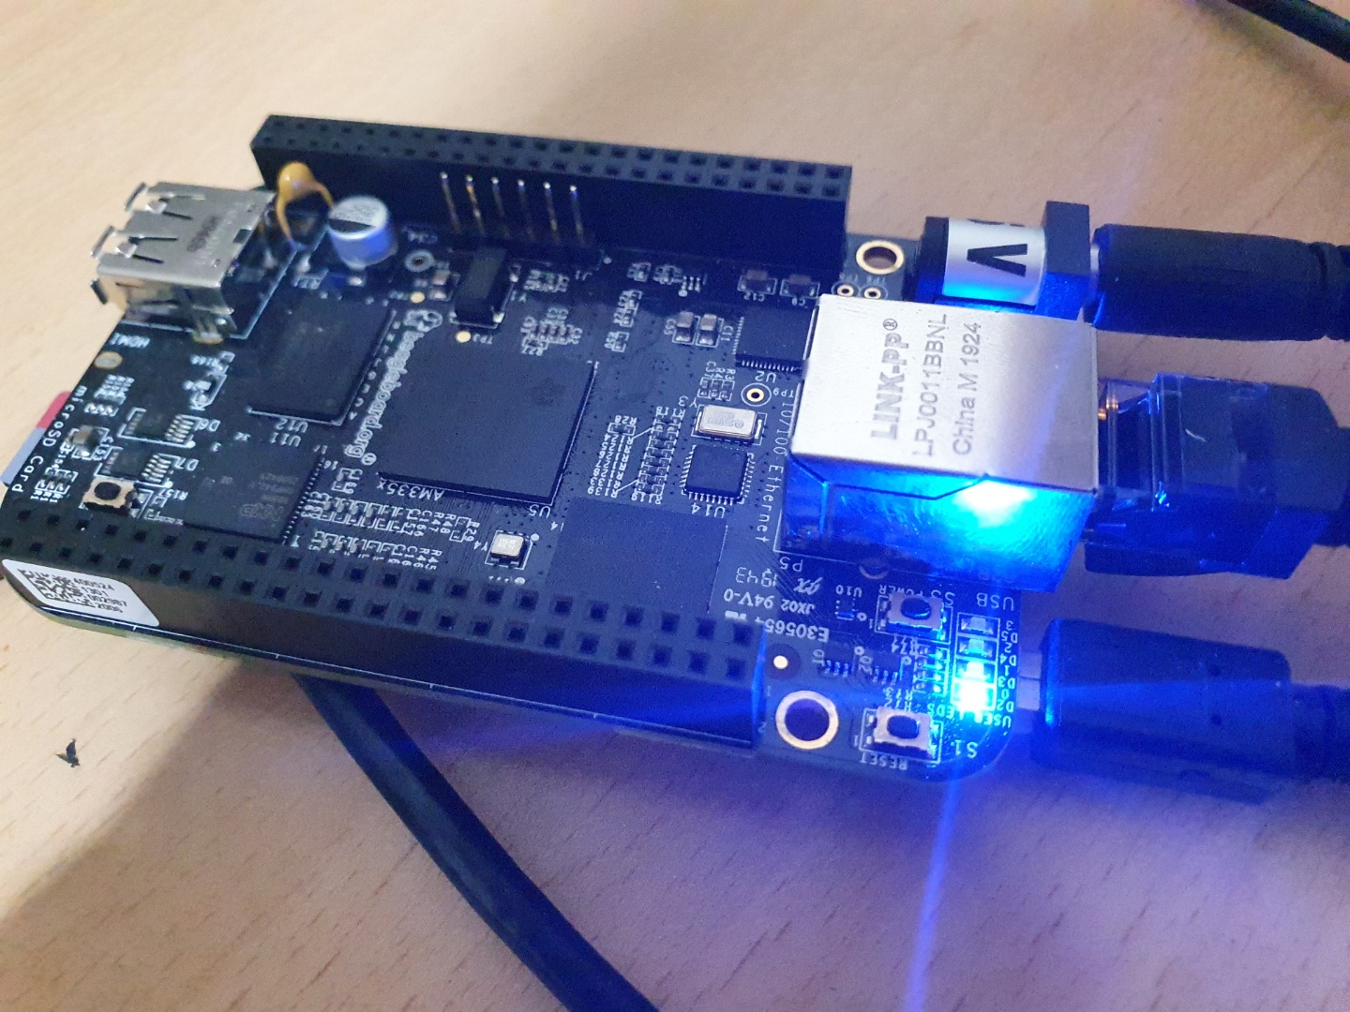

LED blinks with period 1s, 0.1s on when we pass timer to trigger and set delay_on 100, off 900 (difficult to show photo since the duty was too short)

1. Test LEDs with shell script:

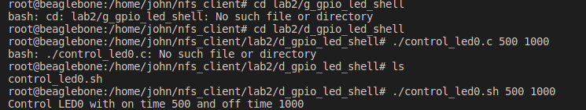

LED blinks with period 1.5s, 1s on and 0.5s off

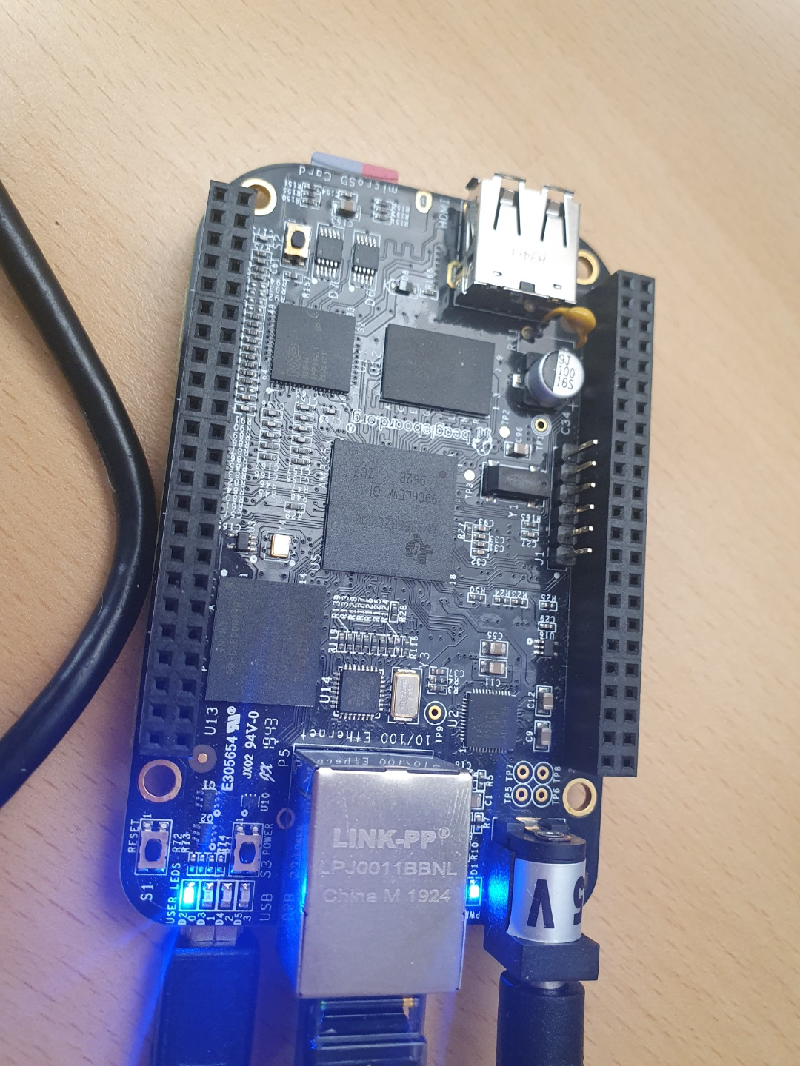

1. Control LED with C and mmap

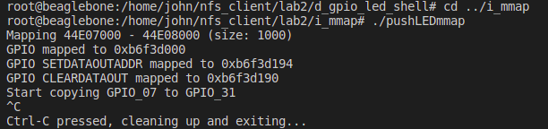

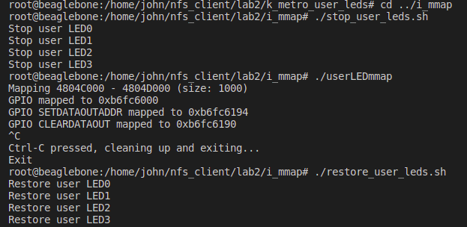

LEDs stop when we run stop_user_leds

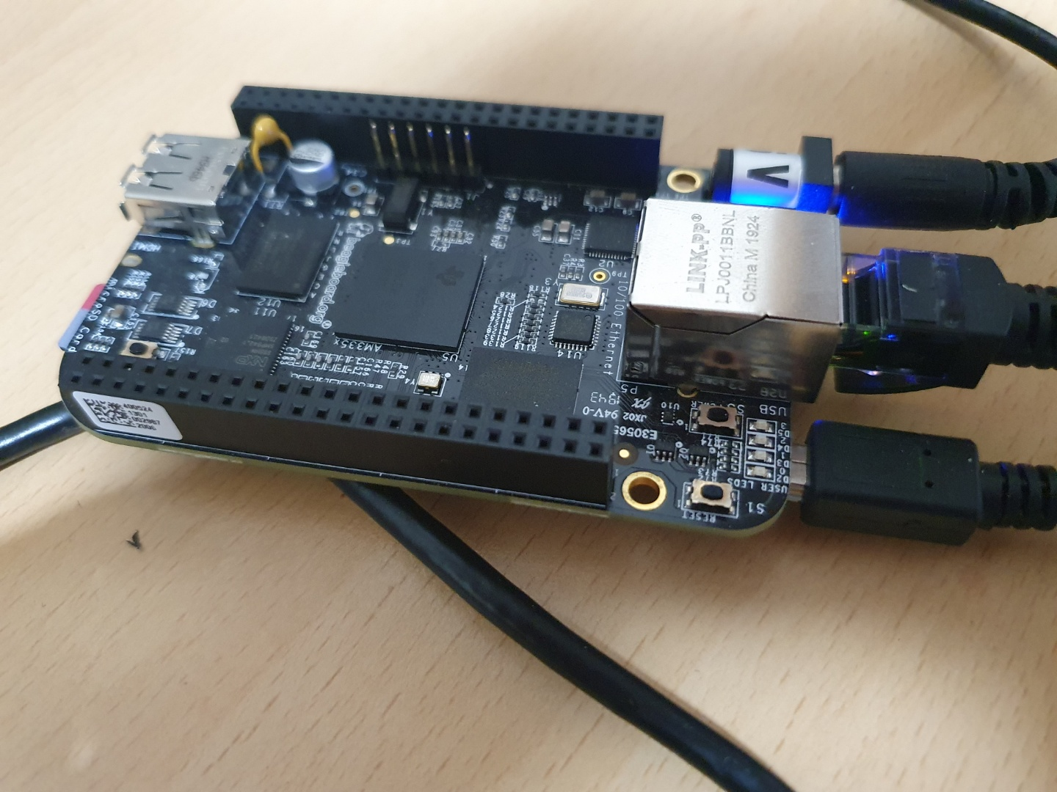

The usr1 LED blinks when we execute usermmapLED

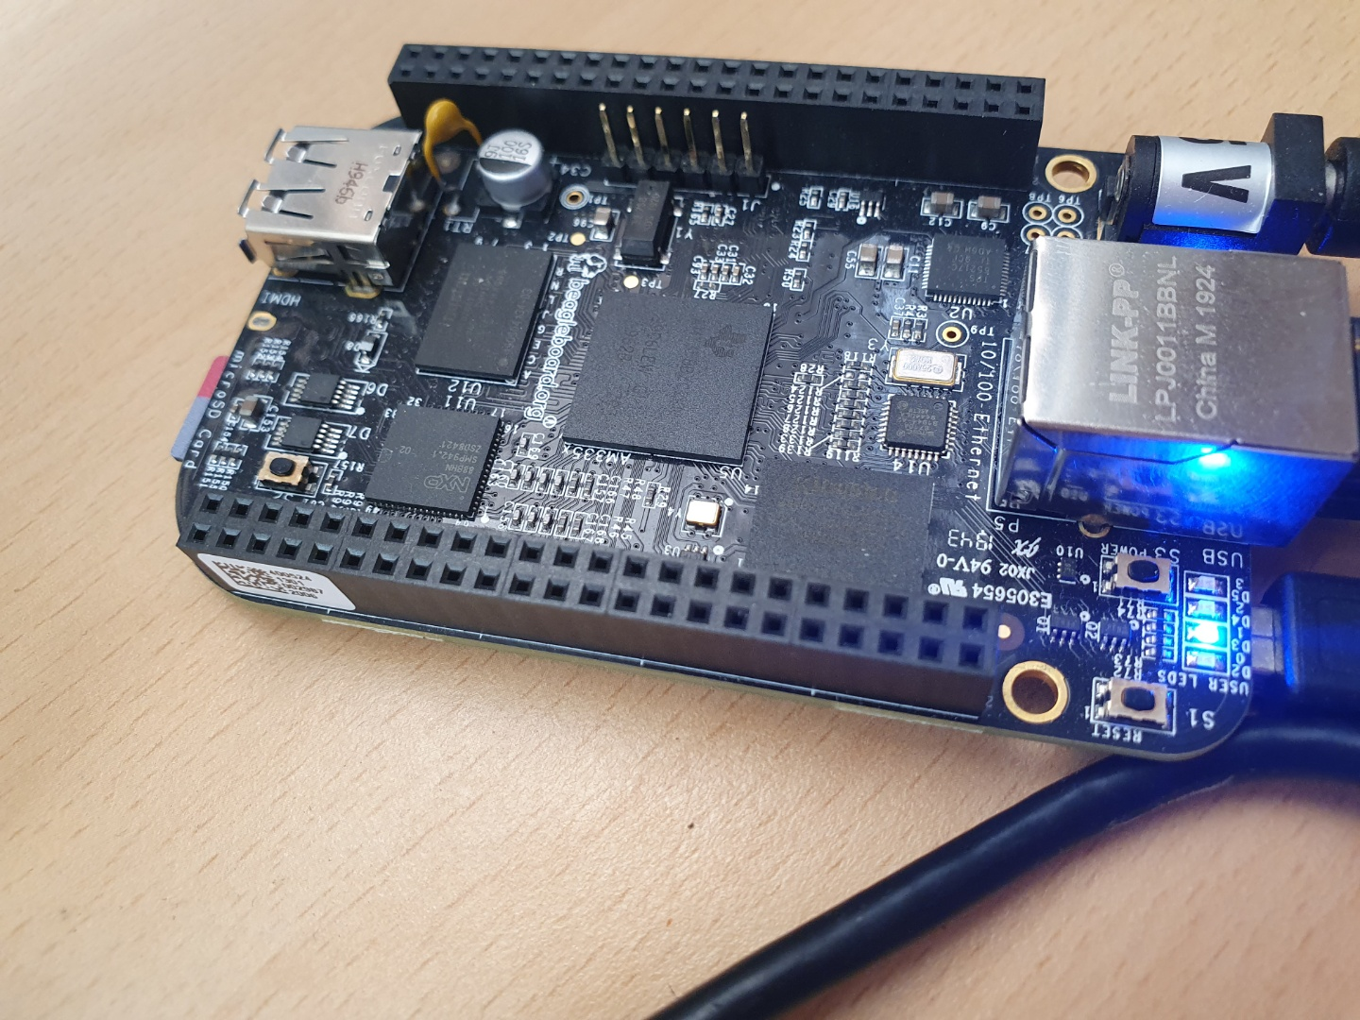

LEDs restore when we run restore_user_leds

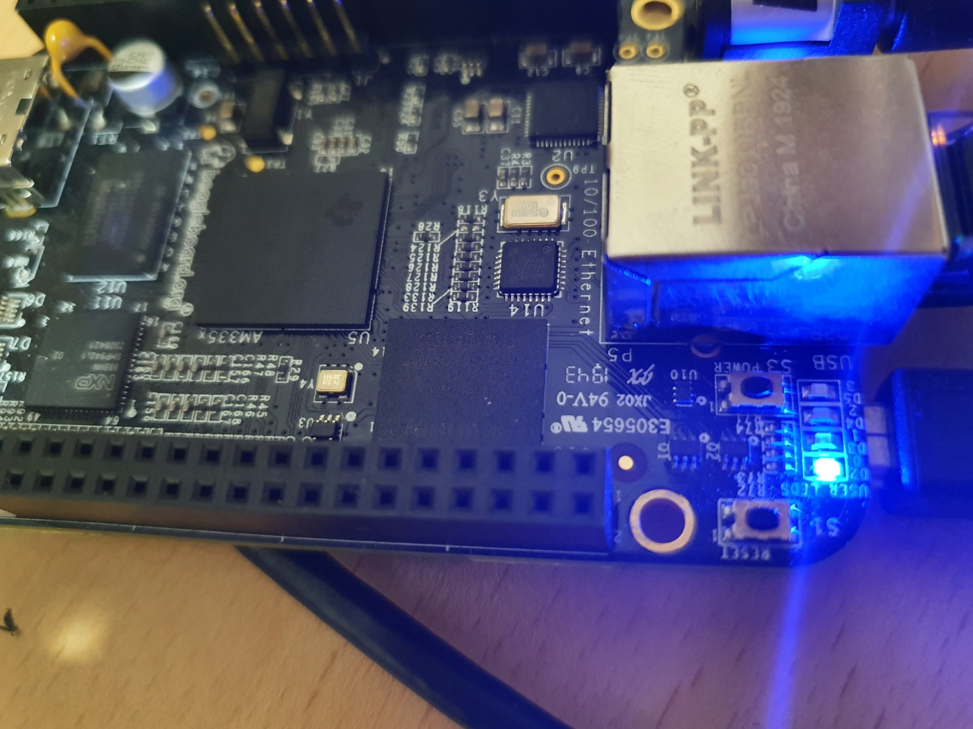

1. Test Metronome_led application program

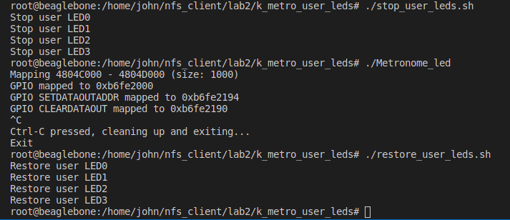

LED runs with 6/8 time signature, 60bpm, duty 50% (please refer to the video)

Discussion:

1. About sysfs and mmap:

Both methods are possible in controlling the GPIO (the LEDs in our case)

|  |  |  |
| --- | --- | --- |
| Method | Sysfs | mmap |
| Mechanism | We access GPIOs via sysfs, a virtual file system available in the Linux kernel.  Drivers for the hardware (including GPIOs) is exposed in sysfs and user can control them. | We use address of the memory mapped to the register.  We manipulate the register via read/write to the addresses for the SETDATAOUT and CLEARDATAOUT registers. |
| Pros | - Can control from shell commands without heavy programming effort.  - More intuitive and faster to develop, might be efficient for prototyping (or simple application). | - More flexible, higher performance due to less CPU usage and less overhead  - Suitable for complex application |
| Cons | - CPU-demanding with many overheads, leading to lower performance.  - Not suitable for complex application | - Require substantial programming effort.  - Less intuitive (need details like mapping between gpio is mapped and memory address) and slower to develop |

1. The use of device driver module in kernel level:

Because user LED is a device, it is controlled by the device driver module in kernel.

* The use of device driver:

Pros: Isolate the user's programs from ready access to critical kernel data structures and hardware devices, hide the complexities of hardware programming from user

* The use of device driver module in kernel

Pros: give more flexibitity, the module itself can be updated in a live kernel without rebooting. Not frequently used module can be loaded when necessary, saving memory for more critical components.

Cons: fragments the memory and driving up the TLB misses, negatively affect the performances, potential security risk or vulnerability.

* The device driver is kernel-level:

Pros: simple implementation, less overhead

Cons: over-occupies kernel code, lower IO performance due to context switches, development restriction (language, debugger, … are limited for kernel-level programming), hard to maintain (due to the bond with kernel)

1. The application program:

The program currently supports 6/8 but we can easily adapt to other time signature using the corresponding sequence.

The time duty and tempo is also configurable

So I think my program is easily expandable to play almost any beat.

V- References:

[1] Getting Started with Beaglebone and Beaglebone Black, http://www.beagleboard.org/Getting%20Started

[2] Beaglebone Rev. A5. System Reference Manual,

http://circuitco.com/support/index.php?title=Beaglebone#Rev_A5. NOTE. The version of Beaglebone boards in the Lab is Rev. A5. Be sure to download the correct version.

[3] “Embedded Linux Primer”, C. Hallinan, Prentice Hall.

[4] Lab material, EE414 Teaching Staffs, KLMS

[5] EBC Exercise series, elinux.org

[6] GPIO Programming series, ics.com

[7] “Loadable kernel module”, Wikipedia

[8] Leslie, Ben & Chubb, Peter & Fitzroy-Dale, Nicholas & Götz, Stefan & Gray, Charles & Macpherson, Luke & Potts, Daniel & Shen, Yue-Ting & Elphinstone, Kevin & Heiser, Gernot. (2005). User-Level Device Drivers: Achieved Performance. J. Comput. Sci. Technol.. 20. 654-664. 10.1007/s11390-005-0654-4.